[](https://ok.ru/dk?cmd=PopLayerPhoto&st.layer.cmd=PopLayerPhotoOuter&st.layer.type=GROUP&st.layer.revNav=off&st.layer.limitedUi=false&st.layer.sphotoIds=836614503220%3B836614502964%3B836614502708%3B836614502452%3B836614502196&st.layer.showNav=on&st.layer.photoAlbumId=57249062780980&st.layer.epm=off&st.layer.photoId=836614503220&st.layer.opl=off&st.layer.navStartPhotoId=836614503220&st.layer.sbd=off&st.cmd=userStatuses&st._aid=GroupTopicLayer_openPhotoLayer)

[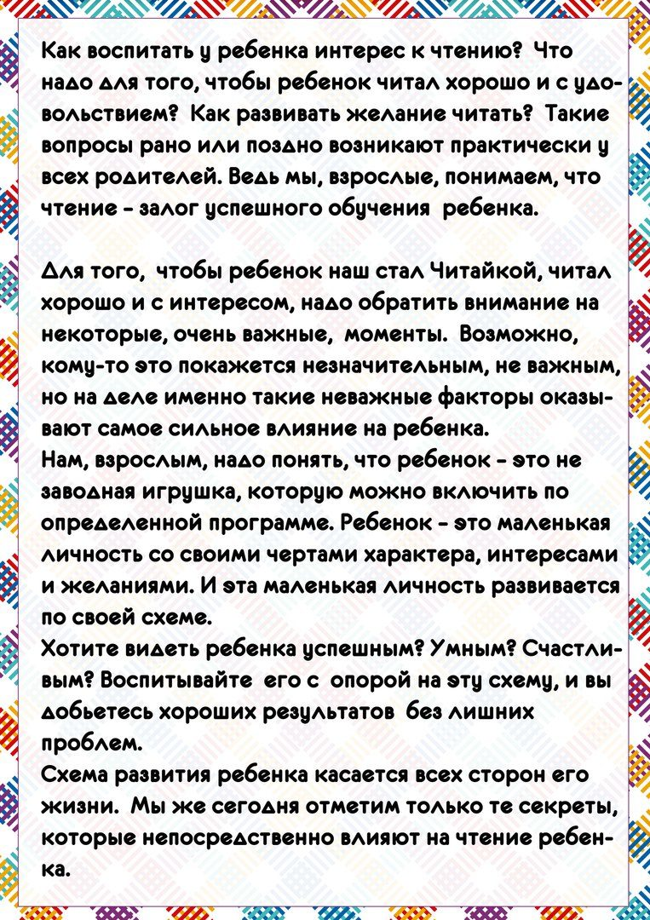](https://ok.ru/dk?cmd=PopLayerPhoto&st.layer.cmd=PopLayerPhotoOuter&st.layer.type=GROUP&st.layer.revNav=off&st.layer.limitedUi=false&st.layer.sphotoIds=836614503220%3B836614502964%3B836614502708%3B836614502452%3B836614502196&st.layer.showNav=on&st.layer.photoAlbumId=57249062780980&st.layer.epm=off&st.layer.photoId=836614502964&st.layer.opl=off&st.layer.navStartPhotoId=836614502964&st.layer.sbd=off&st.cmd=userStatuses&st._aid=GroupTopicLayer_openPhotoLayer)

[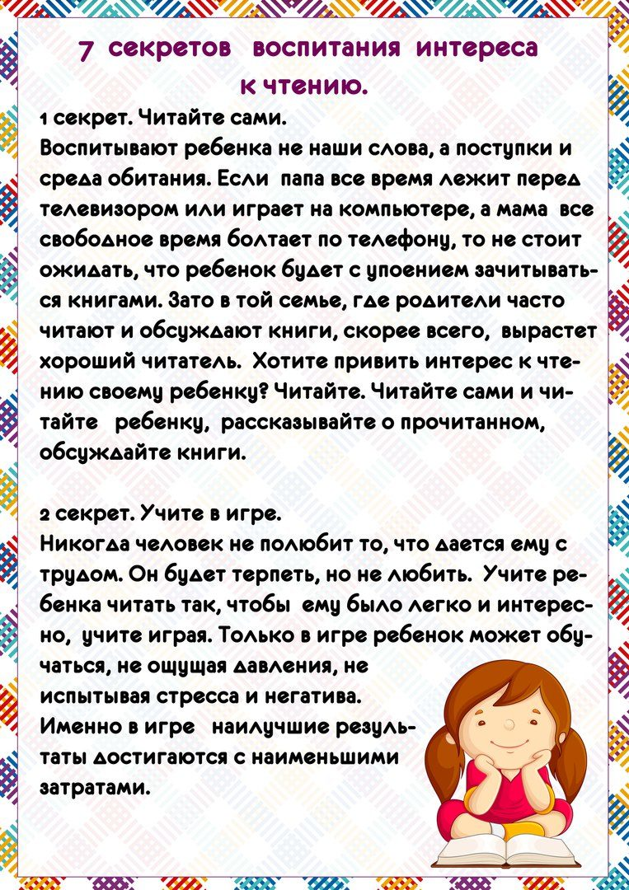](https://ok.ru/dk?cmd=PopLayerPhoto&st.layer.cmd=PopLayerPhotoOuter&st.layer.type=GROUP&st.layer.revNav=off&st.layer.limitedUi=false&st.layer.sphotoIds=836614503220%3B836614502964%3B836614502708%3B836614502452%3B836614502196&st.layer.showNav=on&st.layer.photoAlbumId=57249062780980&st.layer.epm=off&st.layer.photoId=836614502708&st.layer.opl=off&st.layer.navStartPhotoId=836614502708&st.layer.sbd=off&st.cmd=userStatuses&st._aid=GroupTopicLayer_openPhotoLayer)

[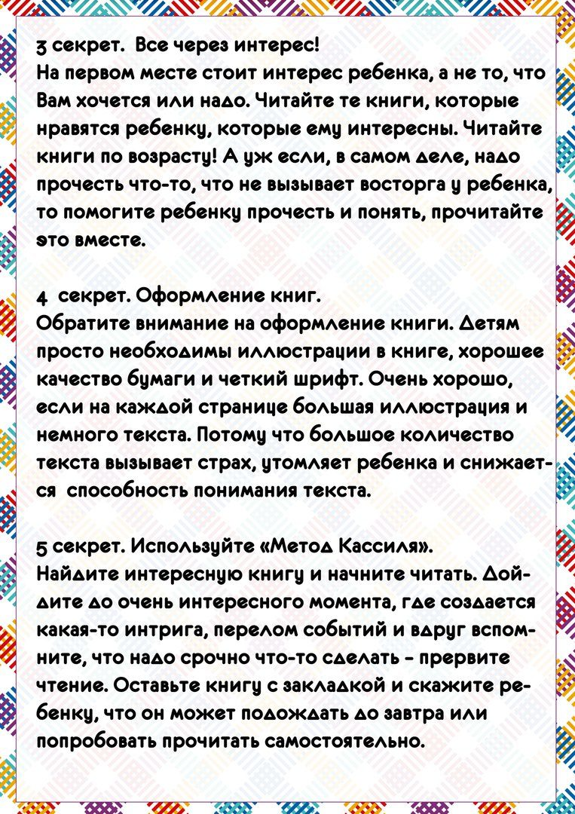](https://ok.ru/dk?cmd=PopLayerPhoto&st.layer.cmd=PopLayerPhotoOuter&st.layer.type=GROUP&st.layer.revNav=off&st.layer.limitedUi=false&st.layer.sphotoIds=836614503220%3B836614502964%3B836614502708%3B836614502452%3B836614502196&st.layer.showNav=on&st.layer.photoAlbumId=57249062780980&st.layer.epm=off&st.layer.photoId=836614502452&st.layer.opl=off&st.layer.navStartPhotoId=836614502452&st.layer.sbd=off&st.cmd=userStatuses&st._aid=GroupTopicLayer_openPhotoLayer)

[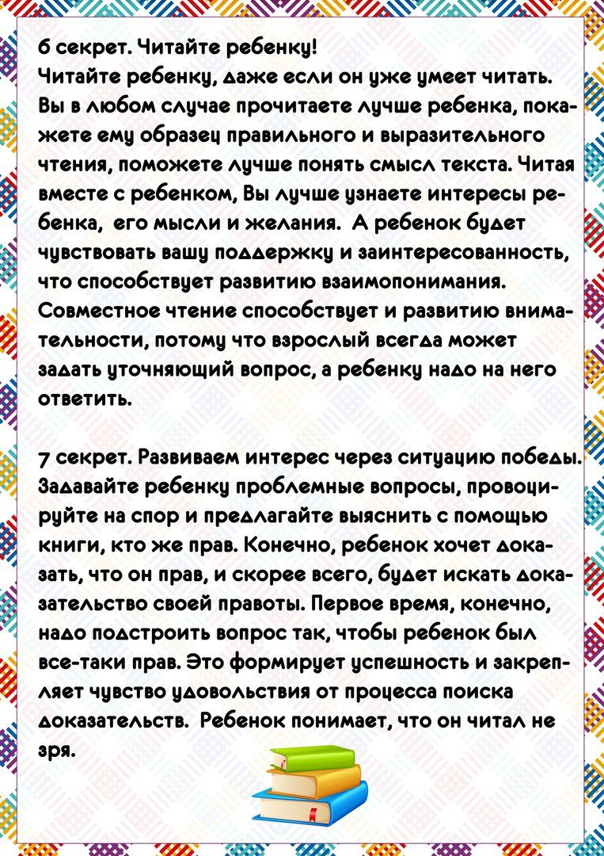](https://ok.ru/dk?cmd=PopLayerPhoto&st.layer.cmd=PopLayerPhotoOuter&st.layer.type=GROUP&st.layer.revNav=off&st.layer.limitedUi=false&st.layer.sphotoIds=836614503220%3B836614502964%3B836614502708%3B836614502452%3B836614502196&st.layer.showNav=on&st.layer.photoAlbumId=57249062780980&st.layer.epm=off&st.layer.photoId=836614502196&st.layer.opl=off&st.layer.navStartPhotoId=836614502196&st.layer.sbd=off&st.cmd=userStatuses&st._aid=GroupTopicLayer_openPhotoLayer)