Развиваем фонематический слух дошкольников

[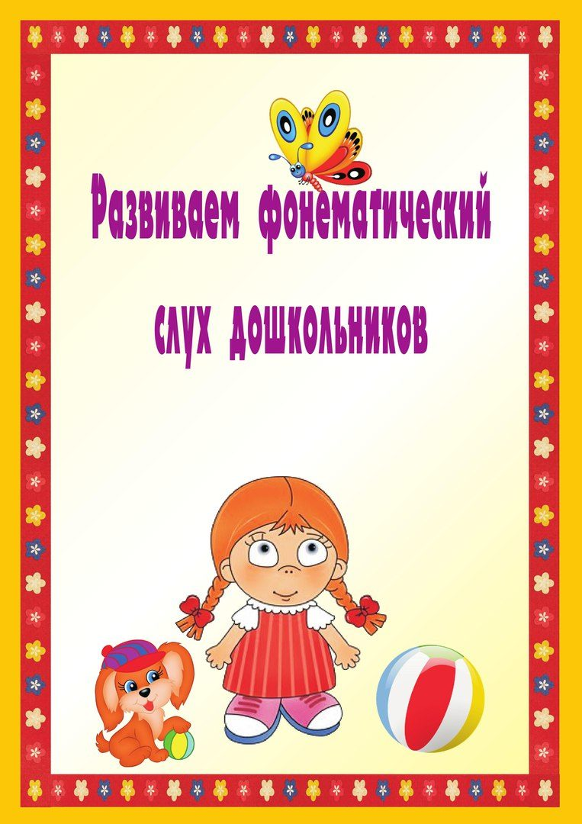](https://ok.ru/dk?cmd=PopLayerPhoto&st.layer.cmd=PopLayerPhotoOuter&st.layer.type=GROUP&st.layer.revNav=off&st.layer.limitedUi=false&st.layer.sphotoIds=816106377908%3B816106377652%3B816106377396%3B816106377140%3B816106376884%3B816106376628%3B816106376372&st.layer.showNav=on&st.layer.photoAlbumId=52069831934132&st.layer.epm=off&st.layer.photoId=816106377908&st.layer.opl=off&st.layer.navStartPhotoId=816106377908&st.layer.sbd=off&st.cmd=userStatuses&st._aid=GroupTopicLayer_openPhotoLayer)

[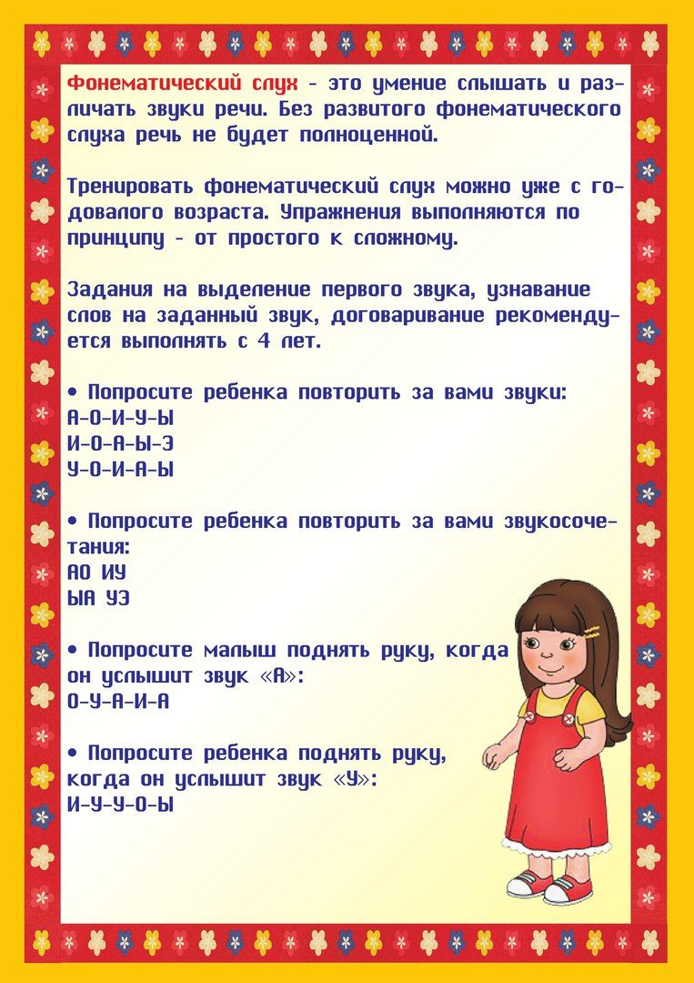](https://ok.ru/dk?cmd=PopLayerPhoto&st.layer.cmd=PopLayerPhotoOuter&st.layer.type=GROUP&st.layer.revNav=off&st.layer.limitedUi=false&st.layer.sphotoIds=816106377908%3B816106377652%3B816106377396%3B816106377140%3B816106376884%3B816106376628%3B816106376372&st.layer.showNav=on&st.layer.photoAlbumId=52069831934132&st.layer.epm=off&st.layer.photoId=816106377652&st.layer.opl=off&st.layer.navStartPhotoId=816106377652&st.layer.sbd=off&st.cmd=userStatuses&st._aid=GroupTopicLayer_openPhotoLayer)

[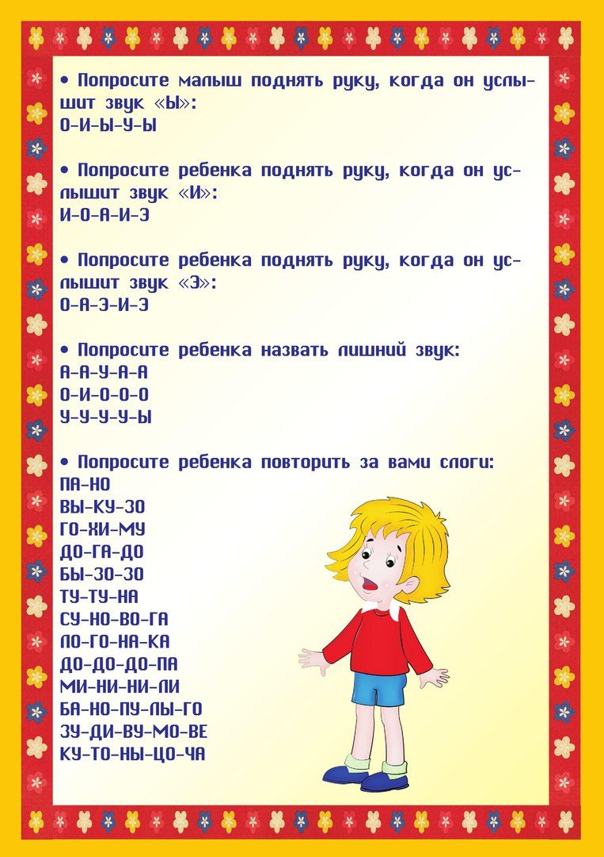](https://ok.ru/dk?cmd=PopLayerPhoto&st.layer.cmd=PopLayerPhotoOuter&st.layer.type=GROUP&st.layer.revNav=off&st.layer.limitedUi=false&st.layer.sphotoIds=816106377908%3B816106377652%3B816106377396%3B816106377140%3B816106376884%3B816106376628%3B816106376372&st.layer.showNav=on&st.layer.photoAlbumId=52069831934132&st.layer.epm=off&st.layer.photoId=816106377396&st.layer.opl=off&st.layer.navStartPhotoId=816106377396&st.layer.sbd=off&st.cmd=userStatuses&st._aid=GroupTopicLayer_openPhotoLayer)

[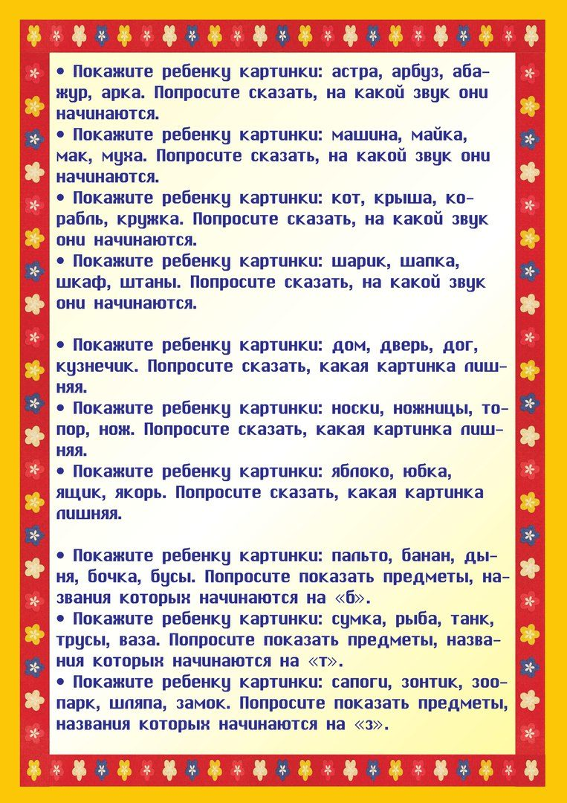](https://ok.ru/dk?cmd=PopLayerPhoto&st.layer.cmd=PopLayerPhotoOuter&st.layer.type=GROUP&st.layer.revNav=off&st.layer.limitedUi=false&st.layer.sphotoIds=816106377908%3B816106377652%3B816106377396%3B816106377140%3B816106376884%3B816106376628%3B816106376372&st.layer.showNav=on&st.layer.photoAlbumId=52069831934132&st.layer.epm=off&st.layer.photoId=816106377140&st.layer.opl=off&st.layer.navStartPhotoId=816106377140&st.layer.sbd=off&st.cmd=userStatuses&st._aid=GroupTopicLayer_openPhotoLayer)

[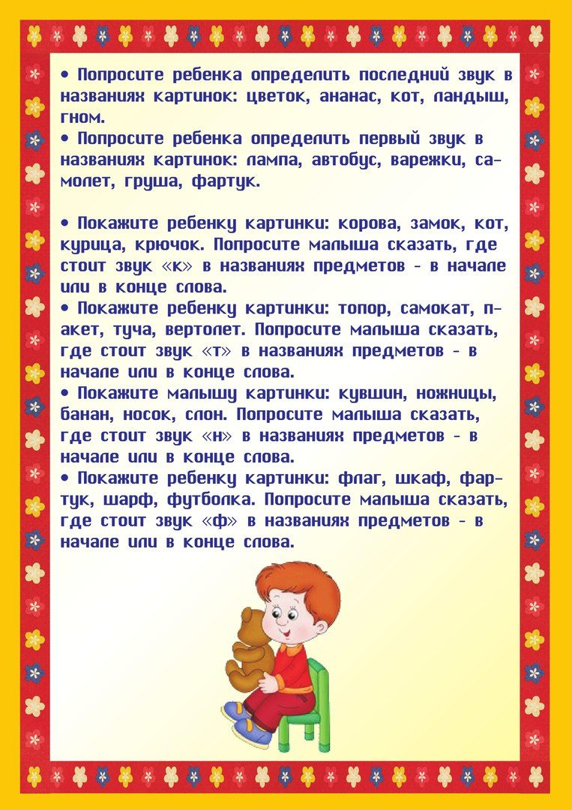](https://ok.ru/dk?cmd=PopLayerPhoto&st.layer.cmd=PopLayerPhotoOuter&st.layer.type=GROUP&st.layer.revNav=off&st.layer.limitedUi=false&st.layer.sphotoIds=816106377908%3B816106377652%3B816106377396%3B816106377140%3B816106376884%3B816106376628%3B816106376372&st.layer.showNav=on&st.layer.photoAlbumId=52069831934132&st.layer.epm=off&st.layer.photoId=816106376884&st.layer.opl=off&st.layer.navStartPhotoId=816106376884&st.layer.sbd=off&st.cmd=userStatuses&st._aid=GroupTopicLayer_openPhotoLayer)

[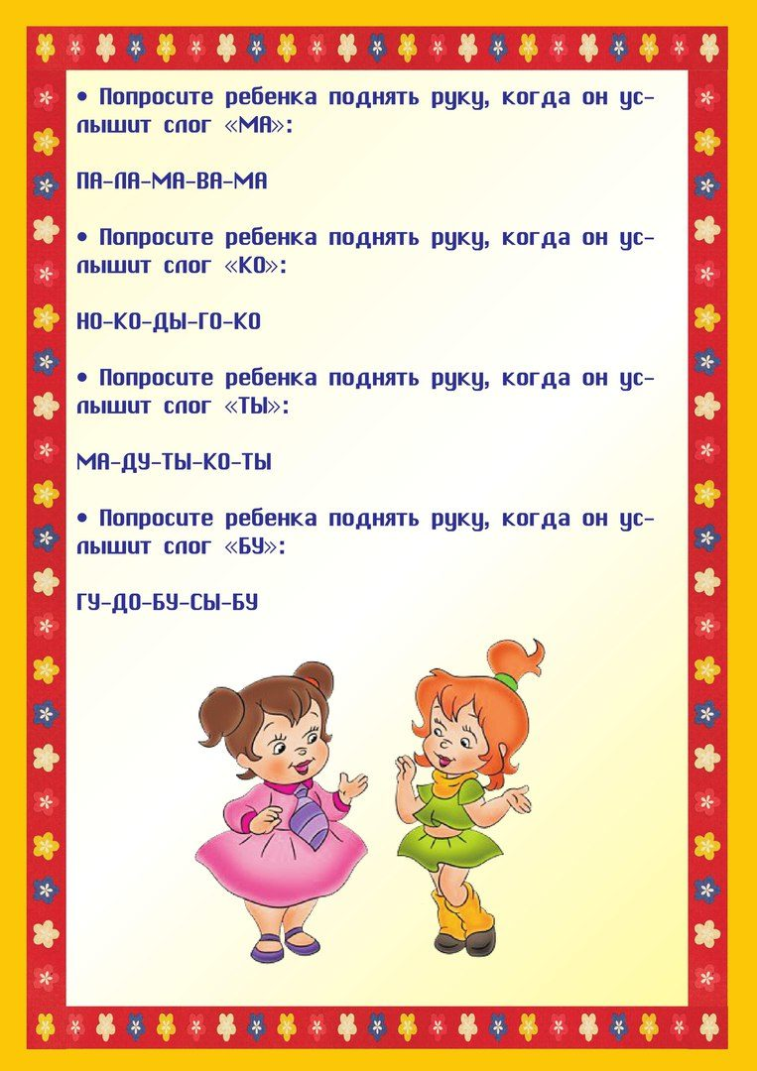](https://ok.ru/dk?cmd=PopLayerPhoto&st.layer.cmd=PopLayerPhotoOuter&st.layer.type=GROUP&st.layer.revNav=off&st.layer.limitedUi=false&st.layer.sphotoIds=816106377908%3B816106377652%3B816106377396%3B816106377140%3B816106376884%3B816106376628%3B816106376372&st.layer.showNav=on&st.layer.photoAlbumId=52069831934132&st.layer.epm=off&st.layer.photoId=816106376628&st.layer.opl=off&st.layer.navStartPhotoId=816106376628&st.layer.sbd=off&st.cmd=userStatuses&st._aid=GroupTopicLayer_openPhotoLayer)

[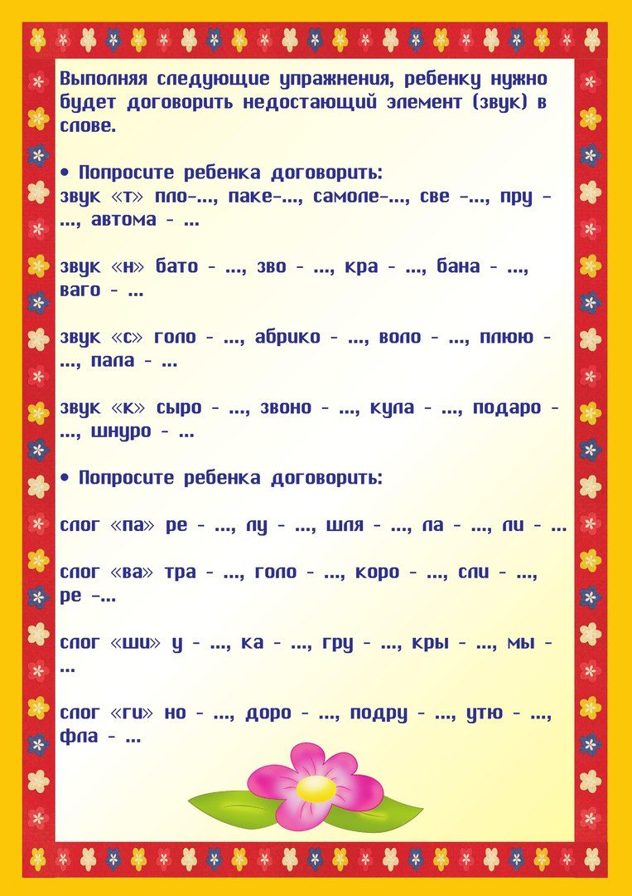](https://ok.ru/dk?cmd=PopLayerPhoto&st.layer.cmd=PopLayerPhotoOuter&st.layer.type=GROUP&st.layer.revNav=off&st.layer.limitedUi=false&st.layer.sphotoIds=816106377908%3B816106377652%3B816106377396%3B816106377140%3B816106376884%3B816106376628%3B816106376372&st.layer.showNav=on&st.layer.photoAlbumId=52069831934132&st.layer.epm=off&st.layer.photoId=816106376372&st.layer.opl=off&st.layer.navStartPhotoId=816106376372&st.layer.sbd=off&st.cmd=userStatuses&st._aid=GroupTopicLayer_openPhotoLayer)