Игры для обучения раннему чтению. Игры со слогами

[](https://ok.ru/dk?cmd=PopLayerPhoto&st.layer.cmd=PopLayerPhotoOuter&st.layer.type=GROUP&st.layer.revNav=off&st.layer.limitedUi=false&st.layer.sphotoIds=836642271156%3B836642270900%3B836642270644%3B836642270388%3B836642270132%3B836642269876%3B836642269620%3B836642269364%3B836642269108&st.layer.showNav=on&st.layer.photoAlbumId=52069831934132&st.layer.epm=off&st.layer.photoId=836642271156&st.layer.opl=off&st.layer.navStartPhotoId=836642271156&st.layer.sbd=off&st.cmd=userStatuses&st._aid=GroupTopicLayer_openPhotoLayer)

[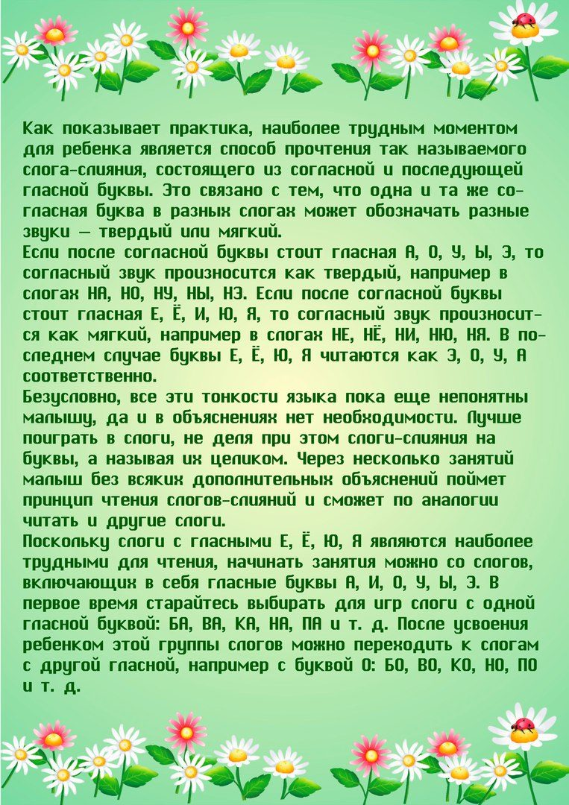](https://ok.ru/dk?cmd=PopLayerPhoto&st.layer.cmd=PopLayerPhotoOuter&st.layer.type=GROUP&st.layer.revNav=off&st.layer.limitedUi=false&st.layer.sphotoIds=836642271156%3B836642270900%3B836642270644%3B836642270388%3B836642270132%3B836642269876%3B836642269620%3B836642269364%3B836642269108&st.layer.showNav=on&st.layer.photoAlbumId=52069831934132&st.layer.epm=off&st.layer.photoId=836642270900&st.layer.opl=off&st.layer.navStartPhotoId=836642270900&st.layer.sbd=off&st.cmd=userStatuses&st._aid=GroupTopicLayer_openPhotoLayer)

[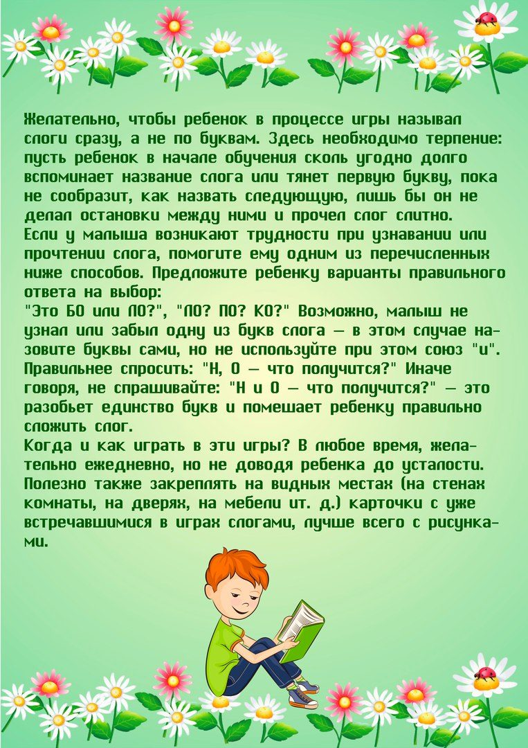](https://ok.ru/dk?cmd=PopLayerPhoto&st.layer.cmd=PopLayerPhotoOuter&st.layer.type=GROUP&st.layer.revNav=off&st.layer.limitedUi=false&st.layer.sphotoIds=836642271156%3B836642270900%3B836642270644%3B836642270388%3B836642270132%3B836642269876%3B836642269620%3B836642269364%3B836642269108&st.layer.showNav=on&st.layer.photoAlbumId=52069831934132&st.layer.epm=off&st.layer.photoId=836642270644&st.layer.opl=off&st.layer.navStartPhotoId=836642270644&st.layer.sbd=off&st.cmd=userStatuses&st._aid=GroupTopicLayer_openPhotoLayer)

[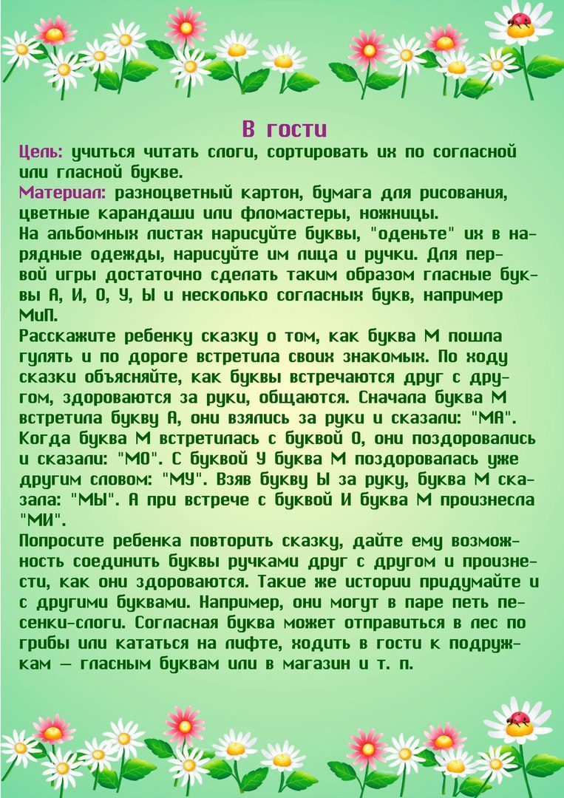](https://ok.ru/dk?cmd=PopLayerPhoto&st.layer.cmd=PopLayerPhotoOuter&st.layer.type=GROUP&st.layer.revNav=off&st.layer.limitedUi=false&st.layer.sphotoIds=836642271156%3B836642270900%3B836642270644%3B836642270388%3B836642270132%3B836642269876%3B836642269620%3B836642269364%3B836642269108&st.layer.showNav=on&st.layer.photoAlbumId=52069831934132&st.layer.epm=off&st.layer.photoId=836642270388&st.layer.opl=off&st.layer.navStartPhotoId=836642270388&st.layer.sbd=off&st.cmd=userStatuses&st._aid=GroupTopicLayer_openPhotoLayer)

[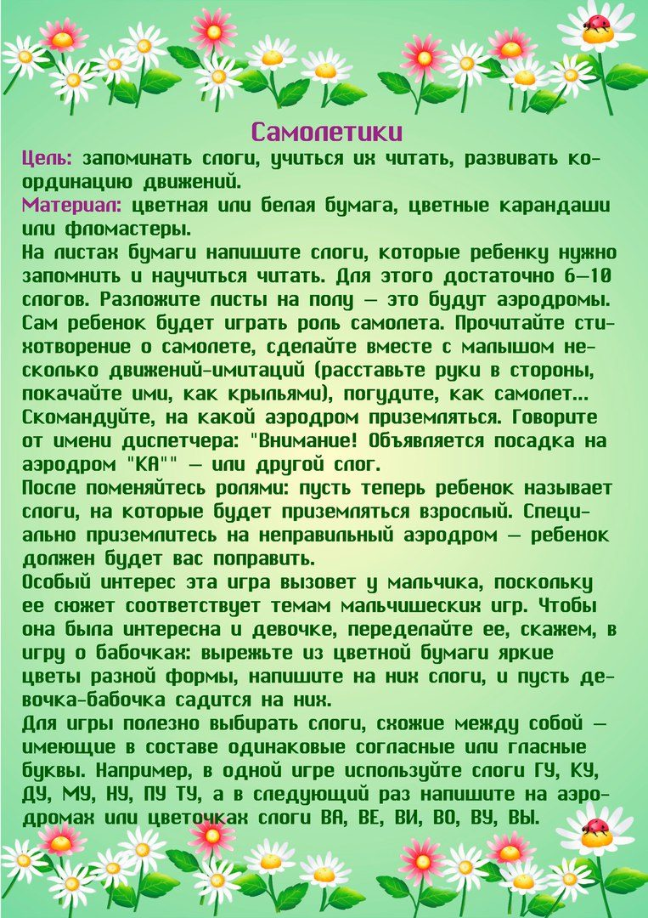](https://ok.ru/dk?cmd=PopLayerPhoto&st.layer.cmd=PopLayerPhotoOuter&st.layer.type=GROUP&st.layer.revNav=off&st.layer.limitedUi=false&st.layer.sphotoIds=836642271156%3B836642270900%3B836642270644%3B836642270388%3B836642270132%3B836642269876%3B836642269620%3B836642269364%3B836642269108&st.layer.showNav=on&st.layer.photoAlbumId=52069831934132&st.layer.epm=off&st.layer.photoId=836642270132&st.layer.opl=off&st.layer.navStartPhotoId=836642270132&st.layer.sbd=off&st.cmd=userStatuses&st._aid=GroupTopicLayer_openPhotoLayer)

[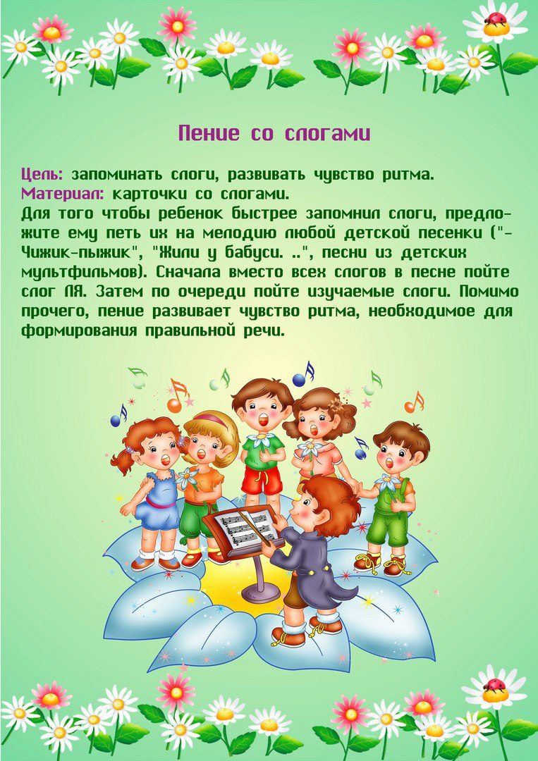](https://ok.ru/dk?cmd=PopLayerPhoto&st.layer.cmd=PopLayerPhotoOuter&st.layer.type=GROUP&st.layer.revNav=off&st.layer.limitedUi=false&st.layer.sphotoIds=836642271156%3B836642270900%3B836642270644%3B836642270388%3B836642270132%3B836642269876%3B836642269620%3B836642269364%3B836642269108&st.layer.showNav=on&st.layer.photoAlbumId=52069831934132&st.layer.epm=off&st.layer.photoId=836642269876&st.layer.opl=off&st.layer.navStartPhotoId=836642269876&st.layer.sbd=off&st.cmd=userStatuses&st._aid=GroupTopicLayer_openPhotoLayer)

[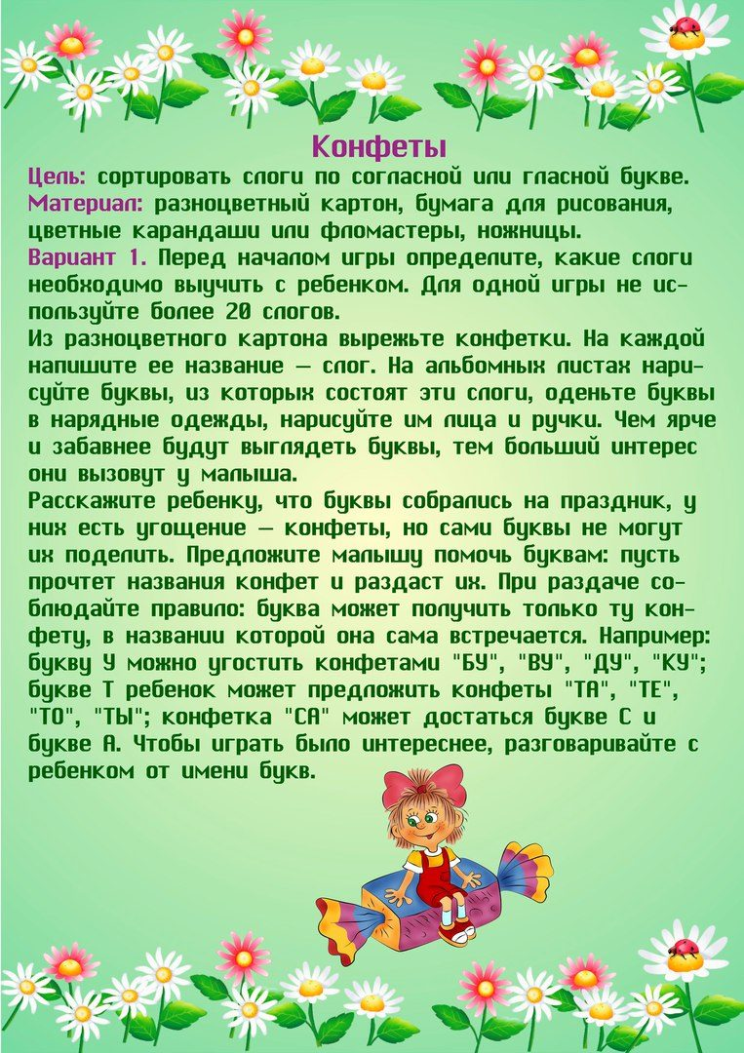](https://ok.ru/dk?cmd=PopLayerPhoto&st.layer.cmd=PopLayerPhotoOuter&st.layer.type=GROUP&st.layer.revNav=off&st.layer.limitedUi=false&st.layer.sphotoIds=836642271156%3B836642270900%3B836642270644%3B836642270388%3B836642270132%3B836642269876%3B836642269620%3B836642269364%3B836642269108&st.layer.showNav=on&st.layer.photoAlbumId=52069831934132&st.layer.epm=off&st.layer.photoId=836642269620&st.layer.opl=off&st.layer.navStartPhotoId=836642269620&st.layer.sbd=off&st.cmd=userStatuses&st._aid=GroupTopicLayer_openPhotoLayer)

[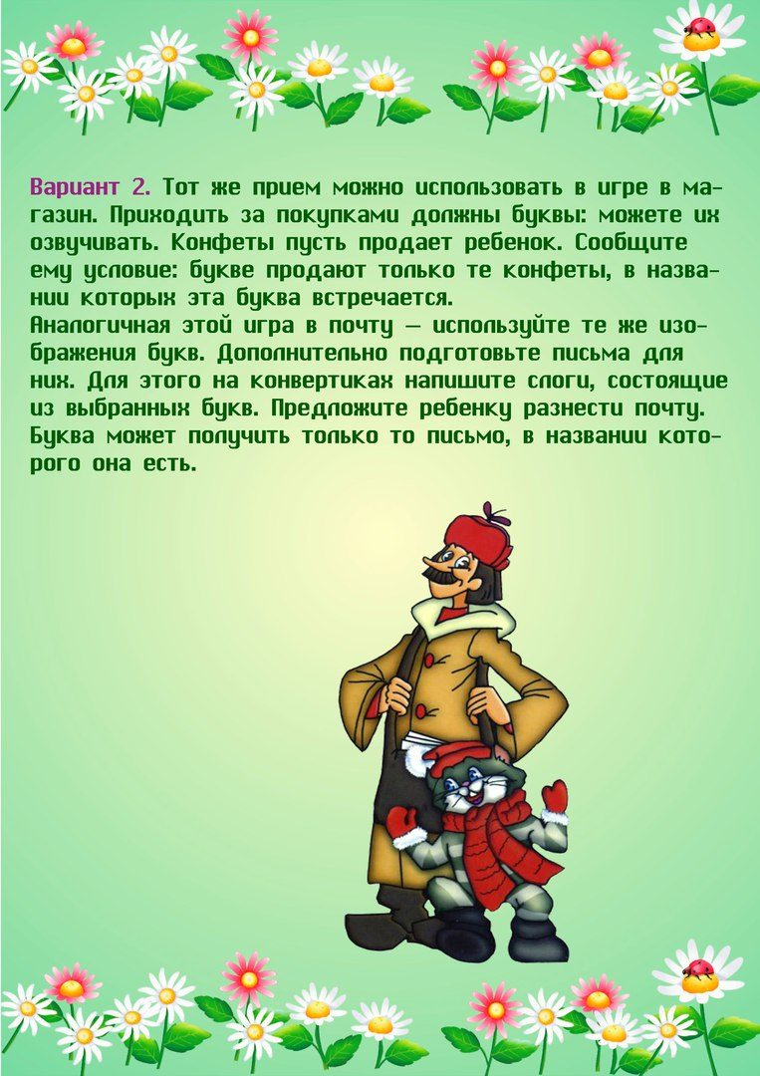](https://ok.ru/dk?cmd=PopLayerPhoto&st.layer.cmd=PopLayerPhotoOuter&st.layer.type=GROUP&st.layer.revNav=off&st.layer.limitedUi=false&st.layer.sphotoIds=836642271156%3B836642270900%3B836642270644%3B836642270388%3B836642270132%3B836642269876%3B836642269620%3B836642269364%3B836642269108&st.layer.showNav=on&st.layer.photoAlbumId=52069831934132&st.layer.epm=off&st.layer.photoId=836642269364&st.layer.opl=off&st.layer.navStartPhotoId=836642269364&st.layer.sbd=off&st.cmd=userStatuses&st._aid=GroupTopicLayer_openPhotoLayer)

[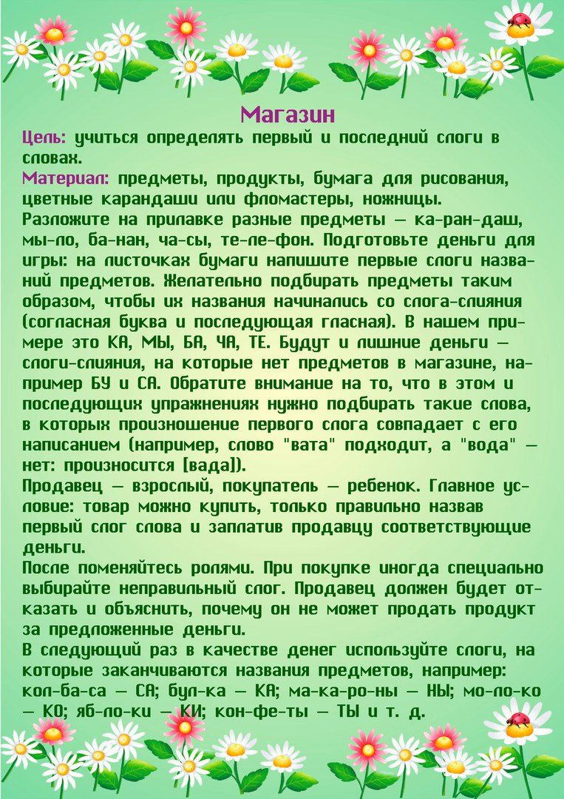](https://ok.ru/dk?cmd=PopLayerPhoto&st.layer.cmd=PopLayerPhotoOuter&st.layer.type=GROUP&st.layer.revNav=off&st.layer.limitedUi=false&st.layer.sphotoIds=836642271156%3B836642270900%3B836642270644%3B836642270388%3B836642270132%3B836642269876%3B836642269620%3B836642269364%3B836642269108&st.layer.showNav=on&st.layer.photoAlbumId=52069831934132&st.layer.epm=off&st.layer.photoId=836642269108&st.layer.opl=off&st.layer.navStartPhotoId=836642269108&st.layer.sbd=off&st.cmd=userStatuses&st._aid=GroupTopicLayer_openPhotoLayer)