МАССАЖ КАРАНДАШАМИ. ПАЛЬЧИКОВЫЕ ИГРЫ И УПРАЖНЕНИЯ

[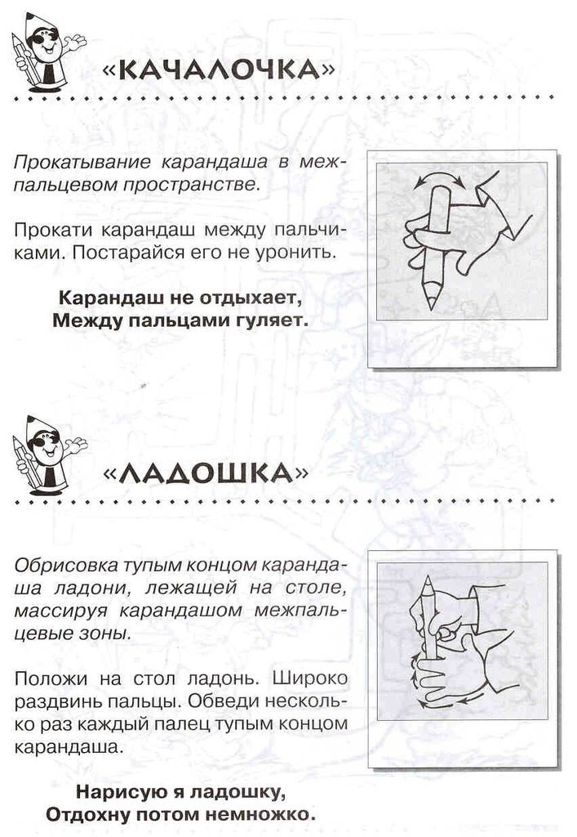](https://ok.ru/dk?cmd=PopLayerPhoto&st.layer.cmd=PopLayerPhotoOuter&st.layer.type=GROUP&st.layer.revNav=off&st.layer.limitedUi=false&st.layer.sphotoIds=837349989893%3B837349989637%3B837349989381%3B837349989125%3B837349988869%3B837349988613&st.layer.showNav=on&st.layer.photoAlbumId=53823353978885&st.layer.epm=off&st.layer.photoId=837349989893&st.layer.opl=off&st.layer.navStartPhotoId=837349989893&st.layer.sbd=off&st.cmd=userStatuses&st._aid=GroupTopicLayer_openPhotoLayer)

[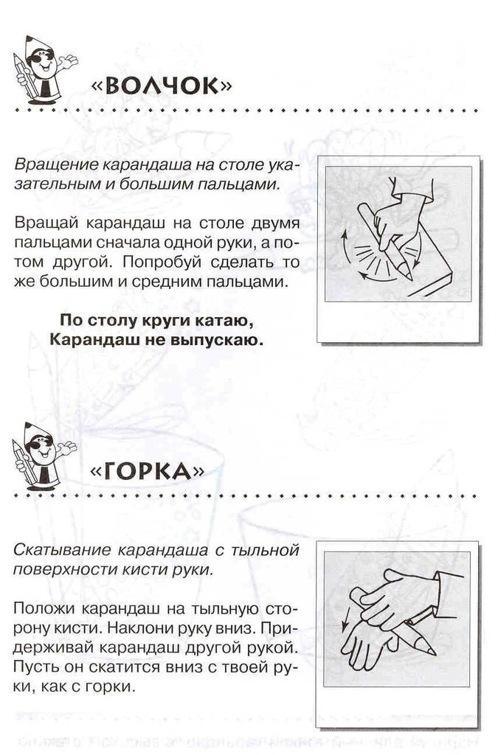](https://ok.ru/dk?cmd=PopLayerPhoto&st.layer.cmd=PopLayerPhotoOuter&st.layer.type=GROUP&st.layer.revNav=off&st.layer.limitedUi=false&st.layer.sphotoIds=837349989893%3B837349989637%3B837349989381%3B837349989125%3B837349988869%3B837349988613&st.layer.showNav=on&st.layer.photoAlbumId=53823353978885&st.layer.epm=off&st.layer.photoId=837349989637&st.layer.opl=off&st.layer.navStartPhotoId=837349989637&st.layer.sbd=off&st.cmd=userStatuses&st._aid=GroupTopicLayer_openPhotoLayer)

[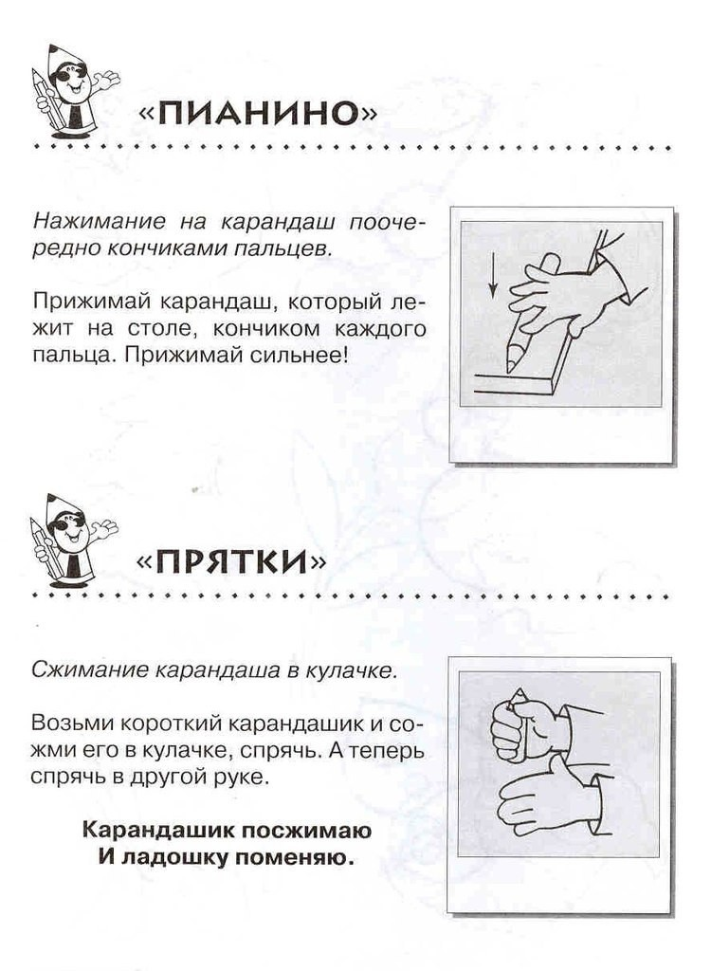](https://ok.ru/dk?cmd=PopLayerPhoto&st.layer.cmd=PopLayerPhotoOuter&st.layer.type=GROUP&st.layer.revNav=off&st.layer.limitedUi=false&st.layer.sphotoIds=837349989893%3B837349989637%3B837349989381%3B837349989125%3B837349988869%3B837349988613&st.layer.showNav=on&st.layer.photoAlbumId=53823353978885&st.layer.epm=off&st.layer.photoId=837349989381&st.layer.opl=off&st.layer.navStartPhotoId=837349989381&st.layer.sbd=off&st.cmd=userStatuses&st._aid=GroupTopicLayer_openPhotoLayer)

[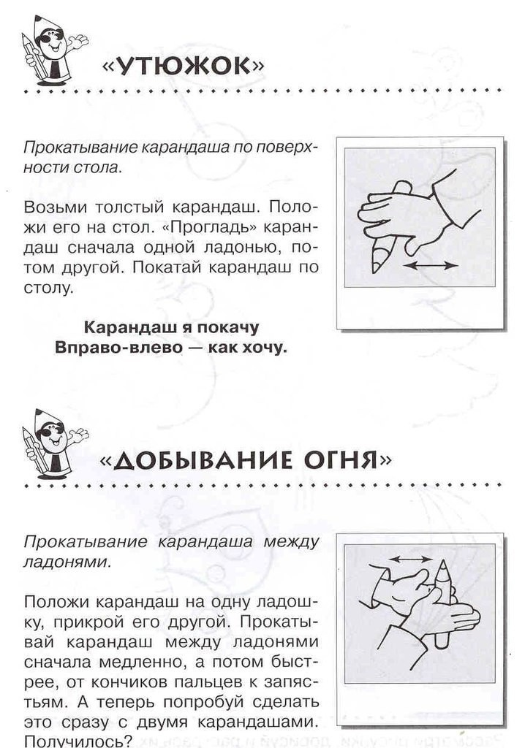](https://ok.ru/dk?cmd=PopLayerPhoto&st.layer.cmd=PopLayerPhotoOuter&st.layer.type=GROUP&st.layer.revNav=off&st.layer.limitedUi=false&st.layer.sphotoIds=837349989893%3B837349989637%3B837349989381%3B837349989125%3B837349988869%3B837349988613&st.layer.showNav=on&st.layer.photoAlbumId=53823353978885&st.layer.epm=off&st.layer.photoId=837349989125&st.layer.opl=off&st.layer.navStartPhotoId=837349989125&st.layer.sbd=off&st.cmd=userStatuses&st._aid=GroupTopicLayer_openPhotoLayer)

[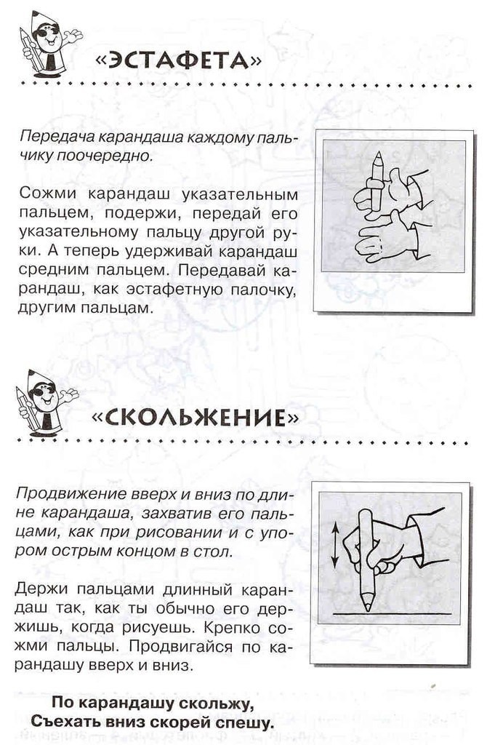](https://ok.ru/dk?cmd=PopLayerPhoto&st.layer.cmd=PopLayerPhotoOuter&st.layer.type=GROUP&st.layer.revNav=off&st.layer.limitedUi=false&st.layer.sphotoIds=837349989893%3B837349989637%3B837349989381%3B837349989125%3B837349988869%3B837349988613&st.layer.showNav=on&st.layer.photoAlbumId=53823353978885&st.layer.epm=off&st.layer.photoId=837349988869&st.layer.opl=off&st.layer.navStartPhotoId=837349988869&st.layer.sbd=off&st.cmd=userStatuses&st._aid=GroupTopicLayer_openPhotoLayer)

[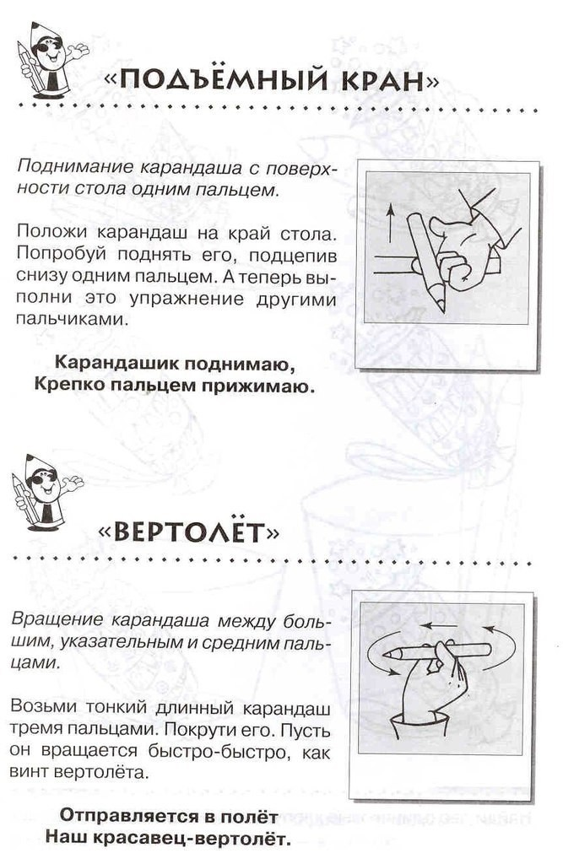](https://ok.ru/dk?cmd=PopLayerPhoto&st.layer.cmd=PopLayerPhotoOuter&st.layer.type=GROUP&st.layer.revNav=off&st.layer.limitedUi=false&st.layer.sphotoIds=837349989893%3B837349989637%3B837349989381%3B837349989125%3B837349988869%3B837349988613&st.layer.showNav=on&st.layer.photoAlbumId=53823353978885&st.layer.epm=off&st.layer.photoId=837349988613&st.layer.opl=off&st.layer.navStartPhotoId=837349988613&st.layer.sbd=off&st.cmd=userStatuses&st._aid=GroupTopicLayer_openPhotoLayer)