***Воспитателям и специалистам ДОУ на заметку***

**Аппликация из ваты "Зимушка-зима"**

[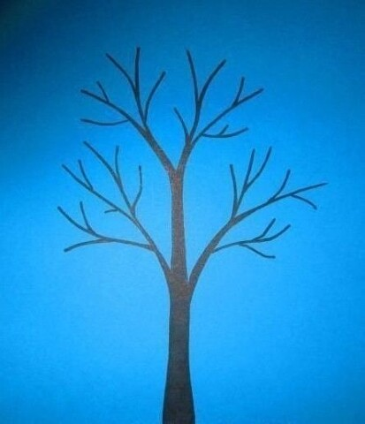](http://m.vseodnoklasniki.com/dk?st.cmd=altGroupPhoto&st.groupId=53660977529012&st.rUrl=/dk?st.cmd%3DaltGroupMediaThemeComments%26amp;st.groupId%3D53660977529012%26amp;st.themeId%3D152560108026036%26amp;st.unrd%3Doff%26amp;_prevCmd%3DaltGroupMediaThemeComments%26amp;tkn%3D903#lst&st.phoId=913386172596&st.albId=53660988735668&_prevCmd=altGroupMediaThemeComments&tkn=1525&_aid=fullTopicPhotoClick)[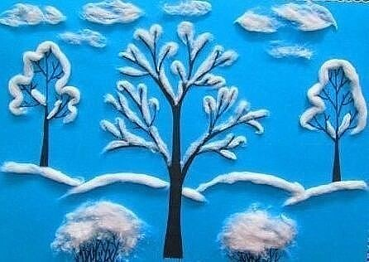](http://m.vseodnoklasniki.com/dk?st.cmd=altGroupPhoto&st.groupId=53660977529012&st.rUrl=/dk?st.cmd%3DaltGroupMediaThemeComments%26amp;st.groupId%3D53660977529012%26amp;st.themeId%3D152560108026036%26amp;st.unrd%3Doff%26amp;_prevCmd%3DaltGroupMediaThemeComments%26amp;tkn%3D1905#lst&st.phoId=913386172852&st.albId=53660988735668&_prevCmd=altGroupMediaThemeComments&tkn=6067&_aid=fullTopicPhotoClick)[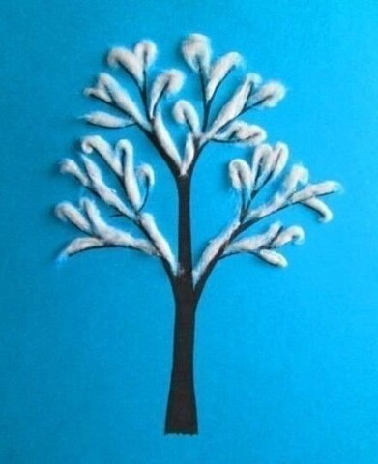](http://m.vseodnoklasniki.com/dk?st.cmd=altGroupPhoto&st.groupId=53660977529012&st.rUrl=/dk?st.cmd%3DaltGroupMediaThemeComments%26amp;st.groupId%3D53660977529012%26amp;st.themeId%3D152560108026036%26amp;st.unrd%3Doff%26amp;_prevCmd%3DaltGroupMediaThemeComments%26amp;tkn%3D7190#lst&st.phoId=913386173108&st.albId=53660988735668&_prevCmd=altGroupMediaThemeComments&tkn=7555&_aid=fullTopicPhotoClick)[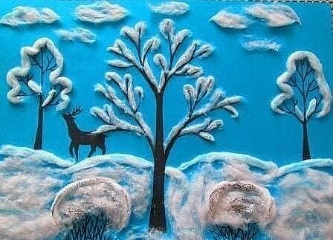](http://m.vseodnoklasniki.com/dk?st.cmd=altGroupPhoto&st.groupId=53660977529012&st.rUrl=/dk?st.cmd%3DaltGroupMediaThemeComments%26amp;st.groupId%3D53660977529012%26amp;st.themeId%3D152560108026036%26amp;st.unrd%3Doff%26amp;_prevCmd%3DaltGroupMediaThemeComments%26amp;tkn%3D5526#lst&st.phoId=913386173364&st.albId=53660988735668&_prevCmd=altGroupMediaThemeComments&tkn=570&_aid=fullTopicPhotoClick)[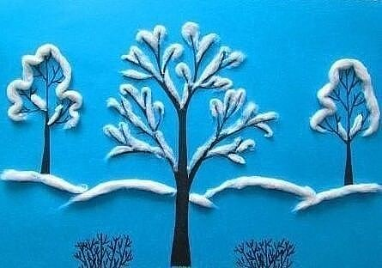](http://m.vseodnoklasniki.com/dk?st.cmd=altGroupPhoto&st.groupId=53660977529012&st.rUrl=/dk?st.cmd%3DaltGroupMediaThemeComments%26amp;st.groupId%3D53660977529012%26amp;st.themeId%3D152560108026036%26amp;st.unrd%3Doff%26amp;_prevCmd%3DaltGroupMediaThemeComments%26amp;tkn%3D4204#lst&st.phoId=913386173620&st.albId=53660988735668&_prevCmd=altGroupMediaThemeComments&tkn=5042&_aid=fullTopicPhotoClick)

**Ёлочки**

[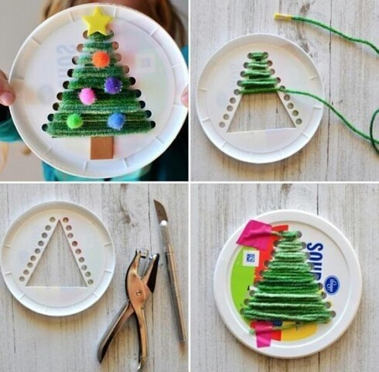](http://m.vseodnoklasniki.com/dk?st.cmd=altGroupPhoto&st.groupId=53660977529012&st.rUrl=/dk?st.cmd%3DaltGroupMediaThemeComments%26amp;st.groupId%3D53660977529012%26amp;st.themeId%3D152559785195700%26amp;st.unrd%3Doff%26amp;_prevCmd%3DaltGroupMediaThemeComments%26amp;tkn%3D1996#lst&st.phoId=913383845812&st.albId=53660988735668&_prevCmd=altGroupMediaThemeComments&tkn=5539&_aid=fullTopicPhotoClick)[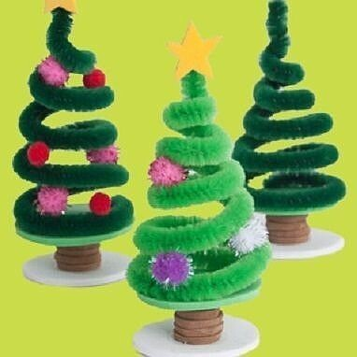](http://m.vseodnoklasniki.com/dk?st.cmd=altGroupPhoto&st.groupId=53660977529012&st.rUrl=/dk?st.cmd%3DaltGroupMediaThemeComments%26amp;st.groupId%3D53660977529012%26amp;st.themeId%3D152559785195700%26amp;st.unrd%3Doff%26amp;_prevCmd%3DaltGroupMediaThemeComments%26amp;tkn%3D8935#lst&st.phoId=913383846068&st.albId=53660988735668&_prevCmd=altGroupMediaThemeComments&tkn=2927&_aid=fullTopicPhotoClick)[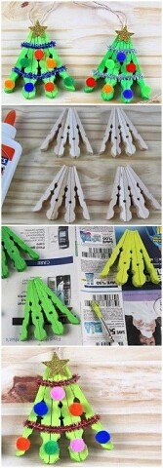](http://m.vseodnoklasniki.com/dk?st.cmd=altGroupPhoto&st.groupId=53660977529012&st.rUrl=/dk?st.cmd%3DaltGroupMediaThemeComments%26amp;st.groupId%3D53660977529012%26amp;st.themeId%3D152559785195700%26amp;st.unrd%3Doff%26amp;_prevCmd%3DaltGroupMediaThemeComments%26amp;tkn%3D7285#lst&st.phoId=913383846324&st.albId=53660988735668&_prevCmd=altGroupMediaThemeComments&tkn=5914&_aid=fullTopicPhotoClick)[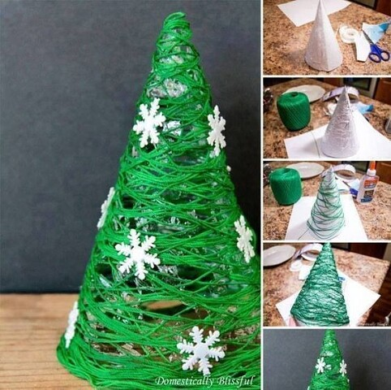](http://m.vseodnoklasniki.com/dk?st.cmd=altGroupPhoto&st.groupId=53660977529012&st.rUrl=/dk?st.cmd%3DaltGroupMediaThemeComments%26amp;st.groupId%3D53660977529012%26amp;st.themeId%3D152559785195700%26amp;st.unrd%3Doff%26amp;_prevCmd%3DaltGroupMediaThemeComments%26amp;tkn%3D6368#lst&st.phoId=913383846580&st.albId=53660988735668&_prevCmd=altGroupMediaThemeComments&tkn=779&_aid=fullTopicPhotoClick)[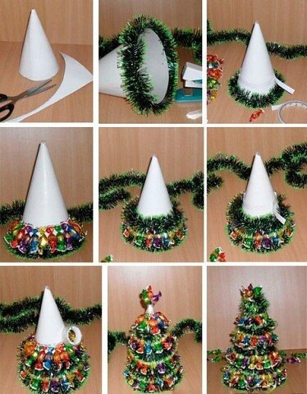](http://m.vseodnoklasniki.com/dk?st.cmd=altGroupPhoto&st.groupId=53660977529012&st.rUrl=/dk?st.cmd%3DaltGroupMediaThemeComments%26amp;st.groupId%3D53660977529012%26amp;st.themeId%3D152559785195700%26amp;st.unrd%3Doff%26amp;_prevCmd%3DaltGroupMediaThemeComments%26amp;tkn%3D7557#lst&st.phoId=913383846836&st.albId=53660988735668&_prevCmd=altGroupMediaThemeComments&tkn=2186&_aid=fullTopicPhotoClick)[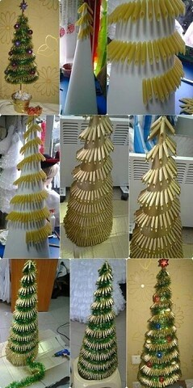](http://m.vseodnoklasniki.com/dk?st.cmd=altGroupPhoto&st.groupId=53660977529012&st.rUrl=/dk?st.cmd%3DaltGroupMediaThemeComments%26amp;st.groupId%3D53660977529012%26amp;st.themeId%3D152559785195700%26amp;st.unrd%3Doff%26amp;_prevCmd%3DaltGroupMediaThemeComments%26amp;tkn%3D7230#lst&st.phoId=913383847092&st.albId=53660988735668&_prevCmd=altGroupMediaThemeComments&tkn=2339&_aid=fullTopicPhotoClick)

**Вырезаем снежинки**

[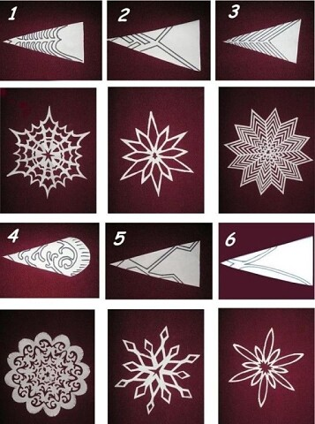](http://m.vseodnoklasniki.com/dk?st.cmd=altGroupPhoto&st.groupId=53660977529012&st.rUrl=/dk?st.cmd%3DaltGroupMediaThemeComments%26amp;st.groupId%3D53660977529012%26amp;st.themeId%3D152560346249396%26amp;st.unrd%3Doff%26amp;_prevCmd%3DaltGroupMediaThemeComments%26amp;tkn%3D746#lst&st.phoId=913389249204&st.albId=53660988735668&_prevCmd=altGroupMediaThemeComments&tkn=3640&_aid=fullTopicPhotoClick)

**Снеговик**

[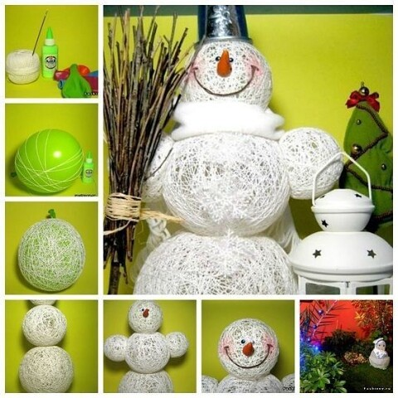](http://m.vseodnoklasniki.com/dk?st.cmd=altGroupPhoto&st.groupId=53660977529012&st.rUrl=/dk?st.cmd%3DaltGroupMediaThemeComments%26amp;st.groupId%3D53660977529012%26amp;st.themeId%3D152558373091508%26amp;st.unrd%3Doff%26amp;_prevCmd%3DaltGroupMediaThemeComments%26amp;tkn%3D1866#lst&st.phoId=913373094068&st.albId=53660988735668&_prevCmd=altGroupMediaThemeComments&tkn=4654&_aid=fullTopicPhotoClick)