Зачем читать детям книги?

[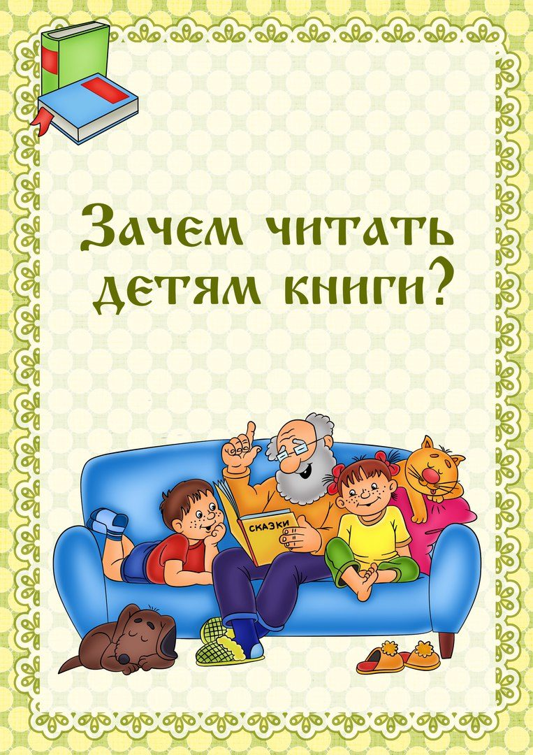](https://ok.ru/dk?cmd=PopLayerPhoto&st.layer.cmd=PopLayerPhotoOuter&st.layer.type=GROUP&st.layer.revNav=off&st.layer.limitedUi=false&st.layer.sphotoIds=835031118597%3B835031118341%3B835031118085%3B835031117829%3B835031117573&st.layer.showNav=on&st.layer.photoAlbumId=53823353978885&st.layer.epm=off&st.layer.photoId=835031118597&st.layer.opl=off&st.layer.navStartPhotoId=835031118597&st.layer.sbd=off&st.cmd=userStatuses&st._aid=GroupTopicLayer_openPhotoLayer)

[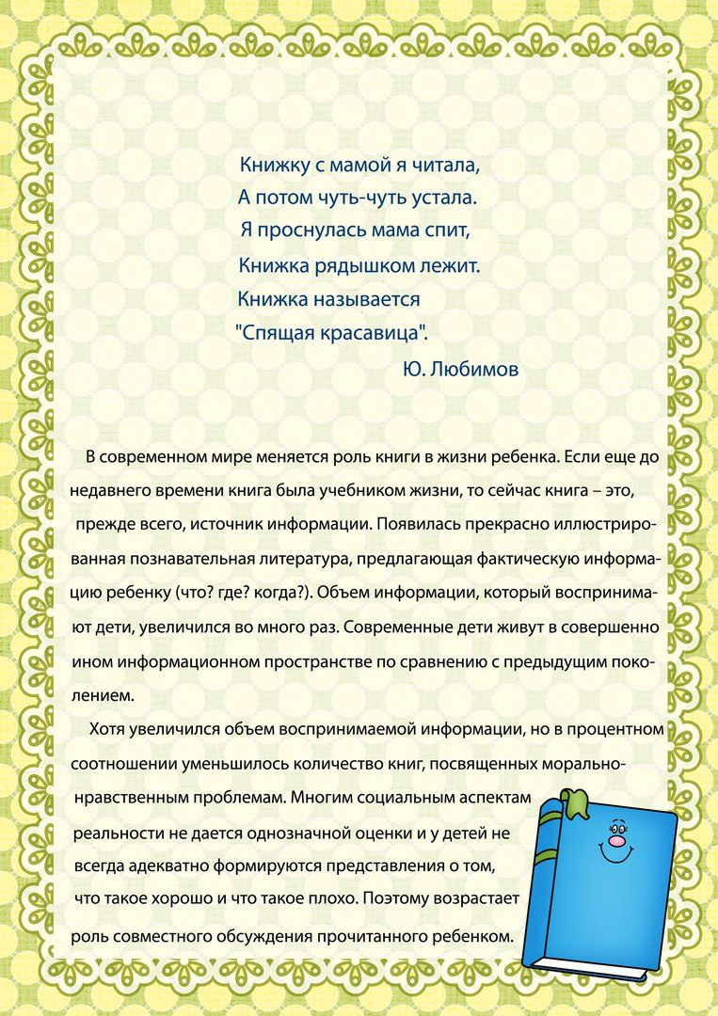](https://ok.ru/dk?cmd=PopLayerPhoto&st.layer.cmd=PopLayerPhotoOuter&st.layer.type=GROUP&st.layer.revNav=off&st.layer.limitedUi=false&st.layer.sphotoIds=835031118597%3B835031118341%3B835031118085%3B835031117829%3B835031117573&st.layer.showNav=on&st.layer.photoAlbumId=53823353978885&st.layer.epm=off&st.layer.photoId=835031118341&st.layer.opl=off&st.layer.navStartPhotoId=835031118341&st.layer.sbd=off&st.cmd=userStatuses&st._aid=GroupTopicLayer_openPhotoLayer)

[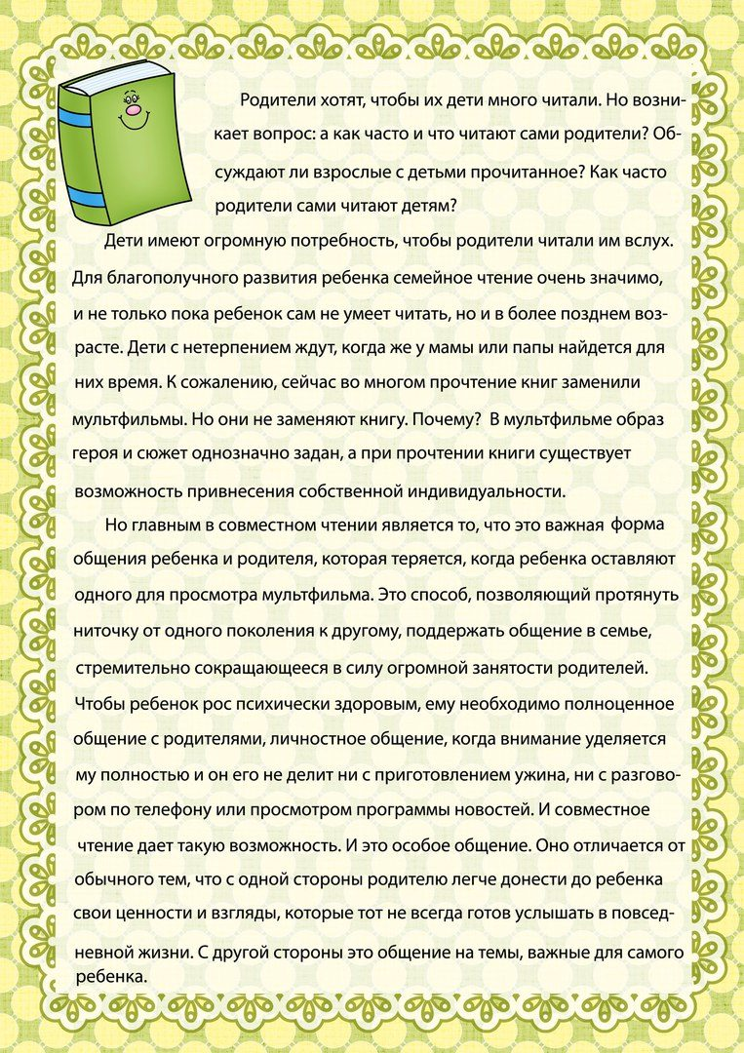](https://ok.ru/dk?cmd=PopLayerPhoto&st.layer.cmd=PopLayerPhotoOuter&st.layer.type=GROUP&st.layer.revNav=off&st.layer.limitedUi=false&st.layer.sphotoIds=835031118597%3B835031118341%3B835031118085%3B835031117829%3B835031117573&st.layer.showNav=on&st.layer.photoAlbumId=53823353978885&st.layer.epm=off&st.layer.photoId=835031118085&st.layer.opl=off&st.layer.navStartPhotoId=835031118085&st.layer.sbd=off&st.cmd=userStatuses&st._aid=GroupTopicLayer_openPhotoLayer)

[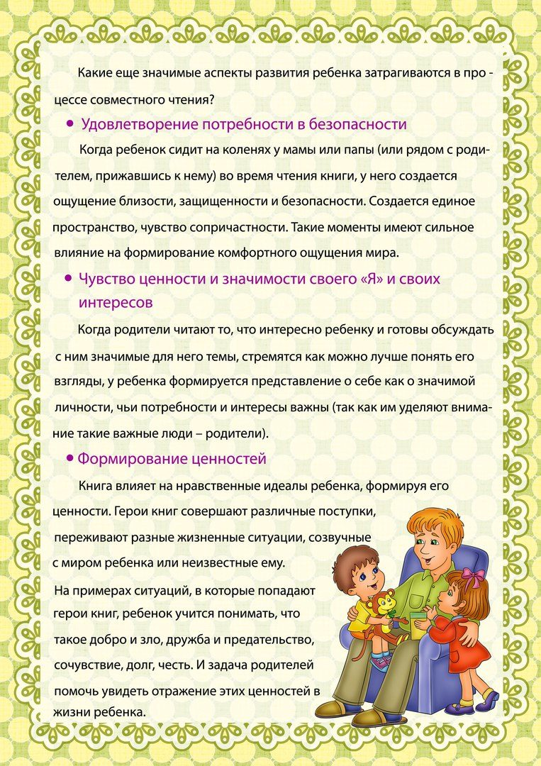](https://ok.ru/dk?cmd=PopLayerPhoto&st.layer.cmd=PopLayerPhotoOuter&st.layer.type=GROUP&st.layer.revNav=off&st.layer.limitedUi=false&st.layer.sphotoIds=835031118597%3B835031118341%3B835031118085%3B835031117829%3B835031117573&st.layer.showNav=on&st.layer.photoAlbumId=53823353978885&st.layer.epm=off&st.layer.photoId=835031117829&st.layer.opl=off&st.layer.navStartPhotoId=835031117829&st.layer.sbd=off&st.cmd=userStatuses&st._aid=GroupTopicLayer_openPhotoLayer)

[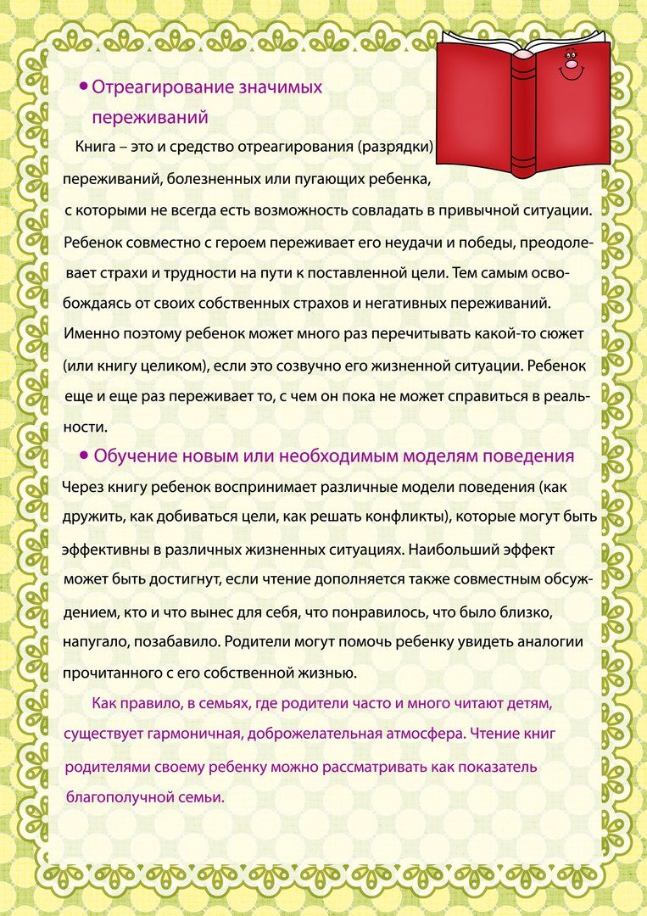](https://ok.ru/dk?cmd=PopLayerPhoto&st.layer.cmd=PopLayerPhotoOuter&st.layer.type=GROUP&st.layer.revNav=off&st.layer.limitedUi=false&st.layer.sphotoIds=835031118597%3B835031118341%3B835031118085%3B835031117829%3B835031117573&st.layer.showNav=on&st.layer.photoAlbumId=53823353978885&st.layer.epm=off&st.layer.photoId=835031117573&st.layer.opl=off&st.layer.navStartPhotoId=835031117573&st.layer.sbd=off&st.cmd=userStatuses&st._aid=GroupTopicLayer_openPhotoLayer)